Design Pattern
Model-View-Controller

General Concept

- Distinction between Data, Illustration and Function
- Allows multiple ways of displaying same data

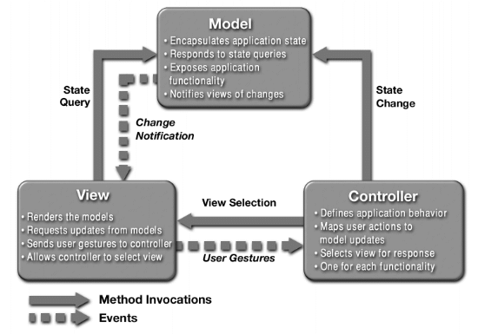

Model

- Complete, encapsulated account of data
- Includes services for manipulation / modification of data
- Encapsulates Application State
- Responds to state queries (from “View”)
- Notifies “views” of changes

  - Responsible for calculations

View

- Renders models
- Requests updates (interactive input)
- Sends gestures to controller

  - Displays the models
  - Responsible for presentation

Controller

- Determines application behavior
- Maps actions
- Selects views for response
- One controller for each functionality

  - Reacts on user input to modify model data
  - Responsible for interaction

Schema

Model
View I
View II
Controller I
Controller II
updates
modifies
modifies
updates

Separation of constituent parts

- Views have to be changeable / creatable without influencing the model
- Model is unaware of details about views, controllers and possibilities of interaction

Example: 2D Drawing Program

Model: Description of elements
- List of drawn elements
- Type (Circle, Square,...)
- Position
- Attributes (Color,...)
- Undo Information,...

View: Graphical realization of the drawing
- List of illustrated elements
- Type, global attributes
- Position in drawing
- local attributes (“highlighted”, “hidden”,...)
- Various graphical illustrations

Controller: Manipulation of drawing
- Usually connected with a view (interaction)

Example: Windows Explorer
Model: as set of files
Views: Large Icons, Small Icons, List, Details, Thumbnails...
Controller: how actions (such as mouse clicking and dragging) are
interpreted.
Note: Some actions change an individual view, other change the shared model.

Advantages | Disadvantages
- Decreases coupling  - Simplifies complex user  interface code  - Multiple controllers for  desired behavior  - Changed object remains  unaware | - Introduces some complexity  - More classes  - More abstractions
- Increases cohesion
- Only the view is concerned
with screen based data
- Improved flexibility
- New views can be added to
one model
- Change of feel w/o change
of look
- Increased reuse
- One model to be
represented in several ways
- Toolkits provided
- Easy development

