The Open Inventor „Teaser”

The Open Inventor, is an object-oriented 3D toolkit. Open Inventor is a library of objects and methods used to create interactive 3D graphics applications. It is written mostly in C++. It is based on Open GL. Inventor objects include database primitives, including shape, property, group, and engine objects; interactive manipulators, such as the handle box and trackball; and components, such as the material editor, directional light editor, and examiner viewer. It has a 3D interchangfe file format, to make it easier to interchange files between different applications.
Inventor represents an object-oriented application policy built on top of OpenGL, providing a programming model and user interface for OpenGL programs.

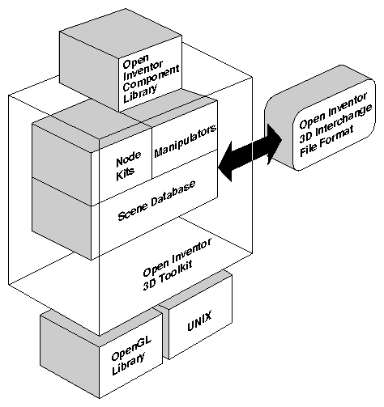

All information about these objects—their shape, size, coloring, surface texture, location in 3D space—is stored in a scene database.

And because the Inventor database holds information about the objects as they exist in their own 3D “world,” not just as a 2D array of pixels drawn on the screen, operations can be performed on the objects themselves. The objects in the scene can be manipulated as discrete entities. What’s more no additional application code is used to make the object animated; this description is part of the object itself.
Open GL & Open Inventor
OpenGL provides immediate-mode access to the frame buffer.

In opposittion Open Inventor does not provide immediate access to the frame buffer. As described previously in the section, it is based on an object-oriented programming model that creates high-level, editable objects stored in a database. Each of these objects encapsulates a set of operations that can be applied to it: rendering, picking, database querying and searching, and bounding-box calculation. In Inventor, rendering to the frame buffer occurs when the render action is invoked.
A simple analogy may help to convey a feel for how Open Inventor contrasts to OpenGL. Suppose it is the year 2020 and you have the time, money, and skills required to build your dream house. You can choose one of two basic approaches, or you can combine elements of both approaches.
The first approach is to go to the Handyperson Builder's Emporium and purchase all the required materials separately—nails, wood, pipes, wires, switches, concrete, and so on. This approach gives you complete flexibility, but it also requires detailed knowledge and skill on your part to determine which parts you need and how to construct all elements of the house.
The second approach is to order a collection of prebuilt units from the Dream Home Catalog, published by a ten-year-old firm that bases its product on concepts of Japanese home building, modular office construction, and the highly successful prefabricated window companies of the 90s. The catalog provides a wide variety of wall-frame units, concrete forms, siding packages, windows, and doors.
The first approach—starting with raw materials—is analogous to using OpenGL for interactive graphics applications. Building a house with this method, you have complete flexibility over how the raw materials are used. You need to be familiar with the details of home construction, and you need different skills to build each part of the home from scratch—plumbing, electrical, carpentry.
The second approach—selecting prebuilt units from a catalog—is loosely analogous to creating an application with Inventor. The wall panels are prewired with the electrical, security, and plumbing connections. This prewiring can be compared to the built-in event model provided by Inventor. In addition, the complete inventory of parts, sizes, and costs is automatically computed by the catalog firm when you place the order. In a similar way, all operations (rendering, picking, bounding-box calculation, and so on) are built into Inventor objects. You do not need to add extra code (or, in the case of the house, perform extra calculations) to obtain this information. Because the catalog company has been buying parts from the Handyperson Builder's Emporium for years, it knows the exact material and sizes to use for maximum economy and minimum waste. Similarly, Open Inventor achieves high performance from its use of OpenGL.
Although the catalog offers a collection of ready-made modules, you have choices about which modules you use and how to put them together.

Inventor, too, allows you to design your own objects (through subclassing, described in The Inventor Toolmaker). With this added flexibility, you are not constrained to the catalog parts, but you can use them to save time and money when they're suitable.

If you want to save even more time, you can choose a complete house kit from the Dream Home Catalog. It offers many different models: A-frame, Ranch, Victorian, Colonial. These house kits are analogous to Inventor's node kits, which provide packaged sets of objects commonly used together.
- 3D scene database that includes shape, property, group, engine, and sensor objects, used to create a hierarchical 3D scene
- A set of node kits that provide a convenient mechanism for creating prebuilt groupings of Inventor nodes
- A set of manipulators, including the handle box and trackball, which are objects in a scene database that the user can interact with directly
- An Inventor Component Library for Xt, including a render area (a window used for rendering), material editor, viewers, and utility functions, used to provide some high-level interactive tasks

The Scene Database
The node is the basic building block used to create three-dimensional scene databases in Inventor. Each node holds a piece of information, such as a surface material, shape description, geometric transformation, light, or camera. All 3D shapes, attributes, cameras, and light sources present in a scene are represented as nodes.
Classes of database primitives include shape nodes (for example, sphere, cube, cylinder, quad mesh), property nodes (for example, material, lighting model, textures, environment), and group nodes (for example, separator, level-of-detail, and switch). Other special database primitives are engines and sensors. Engines are objects that can be connected to other objects in the scene graph and used to animate parts of the scene or constrain certain parts of the scene in relation to other parts (see Chapter 13, “Engines”). A sensor is an object that detects when something in the database changes and calls a function supplied by the application. Sensors can respond to specified timing requirements (for example, “Do this every n seconds”) or to changes in the scene graph data (see Chapter 12, “Sensors”).
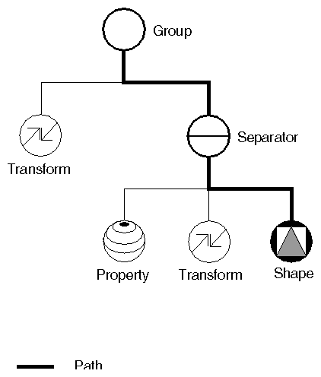

Node Kits
Node kits facilitate the creation of structured, consistent databases. Each node kit is a collection of nodes with a specified arrangement. A template associated with the node kit determines which nodes can be added when necessary and where they should be placed. For example, the SoShapeKit node kit is used for any Inventor shape object. If you use this node kit, you don't have to create and arrange each node individually. By default, the template for the SoShapeKit contains an SoCube node, and it allows a material, geometric transformation, and other properties to be inserted in the correct place when required.
Another use of node kits is to define application-specific objects and semantics. For example, a flight-simulation package might include a variety of objects representing airplanes. Each of these airplanes consists of the same general scene graph structure—for example, fuselage, wings, and landing gear—as well as some airplane-specific methods—for example, bankLeft(), raiseLandingGear(). To an application writer using this package, each type of airplane can be dealt with in a similar way. There is no need to know the details of the structure of the subgraph representing the landing gear to raise it, since the general method, raiseLandingGear(), exists. Creating these new objects and methods requires extending Open Inventor by subclassing, which is described in The Inventor Toolmaker. It is highly recommended that you use some form of node kits in your application to maintain order and policy.

Manipulators
A manipulator is a special kind of node that reacts to user interface events and can be edited directly by the user.

Inventor Component Library
The Inventor Component Library provides window-system support and integration with the X Window System. This library includes the following features:
- A render area (window) object
- Main loop and initialization convenience routines
- An event translator utility
- Editors
- Viewers
The render area accepts an X event, translates it into an Inventor event, and then passes it to “smart” objects, such as manipulators, that may handle the event

    - 2004 - Konrad Lindner – According to the Inventor Mentor documentation

