The paper title goes here
J. Doe¹, P. Dummy¹, M. Mustermann²
¹Technische Universität München, CAMP, {doe,dummy}@cs.tum.edu
²Moscow Institute of Electronic Technology, mustermann@miet.ru
This is the abstract text. It should be a single paragraph with no heading and not more than half a page.

Introduction
Please use this template’s formatting styles. See Figure 1 for how to choose a specific formatting style.
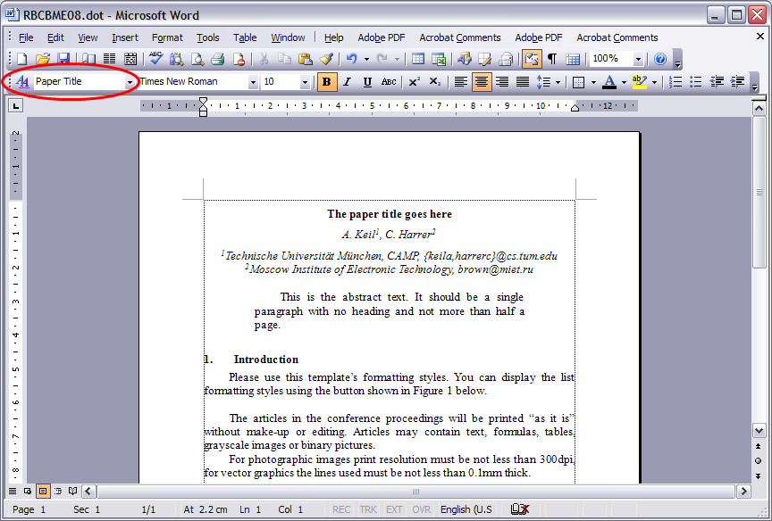
Fig. 1: This is a figure caption. Format figures, tables, and their captions using the style “Figures and Tables” from the Style menu.
The articles in the conference proceedings will be printed “as it is” without make-up or editing. Articles may contain text, formulas, tables, grayscale images or binary pictures.
Formulas must have the same font size as the text (10pt).
For photographic images print resolution must be not less than 300dpi, for vector graphics the lines used must be not less than 0.1mm thick. Text used in pictures must not be less than 9pt.

A Subsection Heading
Bla blubb.

A Subsubsection Heading
More text.

Conclusion
The article must have 2-5 pages in total. Please convert it to PDF if possible. The PDF file must not be locked or secured in order to allow external page numbering insertion (no other editing is supposed).
References
- C. Harrer, S. Kirchhoff, A. Keil, C. Kirchhoff, T. Mussack, A. Lienemann, M. Reiser, N. Navab. Semi-automatic detection of Gd-DTPA-saline filled capsules for colonic transit time assessment in MRI. SPIE 2008.

