Pedicle screw placement under video-augmented flouroscopic control: first clinical application in a cadaver study.
S. M. Heining ª, S. Wiesner^{b}, E. Euler ª, N. Navab^{b}
ª Chirurgische Klinik und Poliklinik, Klinikum der LMU - Innenstadt, Munich, Germany
^{b} Chair for Computer Aided Medical Procedures(CAMP) Technische Universität München Munich, Germany

Abstract.
The pedicle approach for minimally invasive spinal interventions remains an interesting surgical task even after a decade of image-guided surgery in the spine, which has lead to a variety of computer-aided techniques using different imaging modalities.
We present the first clinical application of CAMC, a novel AR (augmented reality) system and our initial experience with imaging of the pedicle approach. Augmented reality is a technique that superimposes acquired patient data e.g. intra-operative imaging data in-situ. This means the imaging data is merged spatially registered with the real view of the region of interest. This creates an intuitive and ergonomic surgical navigation system that enhances minimally invasive procedures.

Keywords: augmented reality visualization; in-situ visualization; navigated surgery; trauma surgery;

1. Introduction
Pedicle screw placement in the lumbar and thoracic spine remains a difficult task in trauma surgery even after a decade of image-guided surgery in the spine, which has lead to a variety of computer-aided techniques using different imaging modalities [3,4,5].
Basic techniques developed from using anatomic descriptions of the entry points in different spinal levels and the typical directions for pedicle screws (“droit devant” [6]) and static x-ray control after instrumentation to intra-operative 2D-flouroscopic control; advanced techniques from CT-based surgical navigation to intra-operative Iso-C-3D-control [5,3].
We present the first clinical application of CAMC, a novel AR (augmented reality) system introduced by Navab et. al. [1], and our initial experience with pedicle screw placement in phantom and cadaver studies. Augmented reality is a technique that superimposes acquired patient data e.g. intra-operative imaging data in-situ. This means the imaging data is merged spatially registered with the real view of the region of interest. This creates an intuitive and ergonomic surgical navigation system that enhances minimally invasive procedures. In this case the X-ray image and optical image share same projection geometry allowing the surgeon to work under video augmented X-ray fluoroscopic control.

2. Methods
We set up a camera augmented mobile c-arm (CAMC) as described in the literature [1,2] and used it to perform pedicle screw placement under video control. After initial phantom studies we carried out two cadaver studies in different levels of the lumbar and thoracic spine using a percutaneous pedicle approach and evaluated the results by CT-control and dissection.
The system hardware uses a prototypic Iso-C-3D fluoroscope (Siemens Medical Solutions, Erlangen) with an additionally attached CCD-camera. The optical axis of video and fluoroscope are aligned via a double mirror construction (Figure 1). After a one-time calibration, the system delivers registered video and x-ray images, which can be merged.

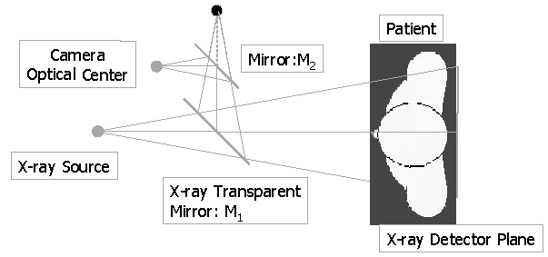

Fig. 1. setup scheme of the double mirror system

During the workflow, two markers for position control are attached. After taking a single x-ray-shot, the image is merged with the video image (Figure 2). Definition of the entry point and placement of the tool-tip accordingly are carried out under video-control (Figure 2). After alignment of the tool’s axis with the optical axis, drilling “down the beam” can be started (Figure 3). If markers do not coincide in video and x-ray images, the patient has moved and therefore a new x-ray image has to be taken.

3. Results
The described CAMC-system enables robust 2-dimensional AR-visualization of everyday surgical tasks with a modified mobile c-arm. The hardware-modifications in this prototype lead to a slightly reduced distance between radiation source and image intensifier; the c-arm has to be used in upside-down configuration. The one-time-calibration was stable during the whole series of experiments. Optical control of attached markers enables detection of possible errors or movement of the specimens.
During spinal interventions via pedicle approach a considerable reduction in flouroscopy time and thus radiation dose can be reduced, as a single-shot x-ray image is sufficient as soon as the pedicle axis is recognized. Nevertheless a new x-ray can be taken at any time for updating the intervention (movement, implants). Pedicle identification and needle insertion was possible in all cases. Modified instruments are required regarding the identification of the instrument axis (Figure 3) and tracking of the instrument enables the visualization of the tip of the instrument even after entering the surface (skin/draping).
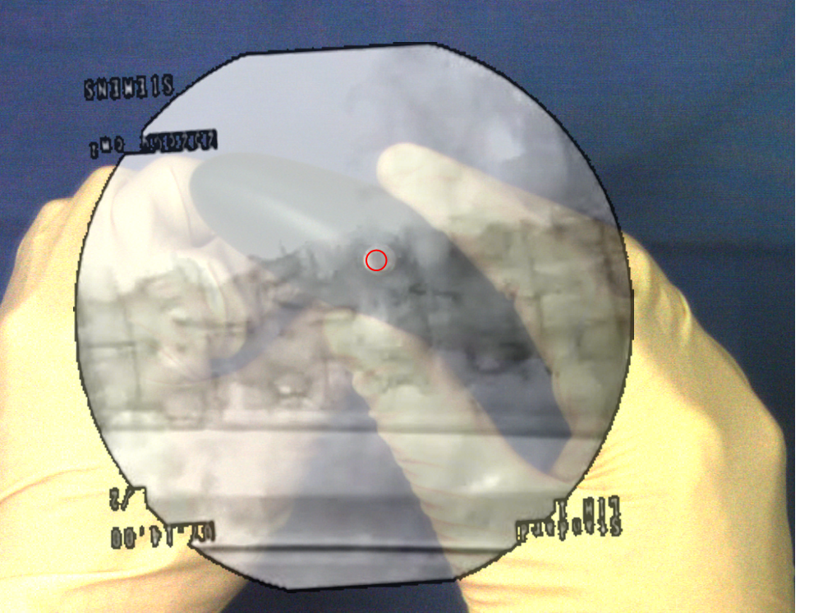

Fig. 2. merged x-ray/video-image during percuntaneous spinal intervention (pedicle approach)

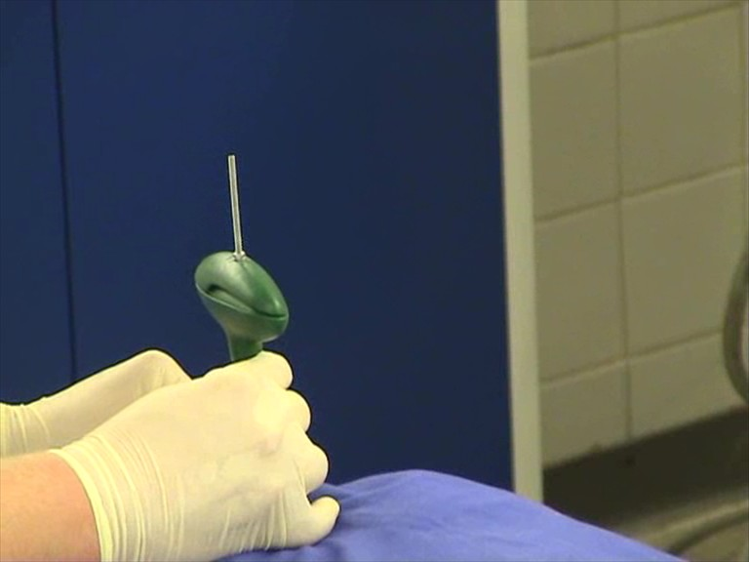

Fig. 3. external view of the procedure shown in figure 2; modified needle tool
As the CAMC-system is integrated into the mobile c-arm no extra hardware like external tracking cameras or additional monitors are needed, thus enhancing the imaging possibilities in the OR without major interference with the surgical workflow. Surgery can start right away without any registration procedures.

4. Conclusion
The camera augmented mobile c-arm (CAMC) proves to be an everyday surgical tool for minimally invasive procedures carried out under flouroscopic control. It enhances the surgeons vision creating an x-ray-view from the beginning of the operation (e.g. portal placement), while reducing radiation time by a significant amount. C ommonly used surgical instruments need modifications in order to identify the axis of the instruments under video-control. Updated X-ray images can be obtained at any time during the intervention by taking a new fluoroscopic shot. The surgical workflow is not compromised and the user-interface provides intuitive control of the system. Further investigations needs to be done in order to create video-based surgical navigation system, which could make the use of multiple X-ray acquisitions and external tracking systems unnecessary.

References
[1] Merging visible and invisible: two camera-augmented mobile C-arm (CAMC) applications; N. Bani- Hashemi, M. Mitschke, Proceedings, 2nd IEEE and ACM International Workshop on Augmented Reality (IWAR'99); Oct. 1999; p. 134-41.
[2] Interventions under Video-Augmented X-RayGuidance: Application to Needle Placement, M. Mitschke, A. Bani-Hashemi, and N. Navab - MICCAI 2000, LNCS 1935, pp. 858–868, 2000.c Springer-Verlag Berlin Heidelberg 2000
[3] C-arm-based three-dimensional navigation: a preliminary feasibility study.
Euler E, Heining S, Riquarts C, Mutschler W. Comput Aided Surg. 2003;8(1):35-41
[4] Pedicle screw placement in the thoracic spine: a comparison of image-guided and manual techniques in cadavers. Hart RA, Hansen BL, Shea M, Hsu F, Anderson GJ. Spine. 2005 Jun 15;30(12):E326-31
[5] Image-guided insertion of transpedicular scres. A laboratory set-up. Nolte LP, Zamorano LJ, Jiang Z, Wnag Q, Langlotz F, Berlemann U. Spine 1995 Feb15;20(4):497-500.
[6] Internal fixation of the lumbar spine with pedicle screw plating. Roy-Camille R, Saillant G, Mazel C. Clin Orthop Relat Res. 1986 Feb;(203):7-17.

